Main title of the paper – style "MAIN TITLE"
Complete Research, Research in Progress, Poster
(Choose one by deleting the others)

Only once the paper is accepted, place the author information here for the final version using style "Authors" as illustrated below:
Smith, Ellen, University of Trinithlon, Trinithlon, UK, ellen.smith@utri.ac.uk
Jönsson, Mikael, University of Oxenhagen, Oxenhagen, Sweden, mikael.jonsson@inf.uox.se

The review process is double blind. Therefore papers submitted for review MUST NOT contain any author information – neither on the title page nor in the page header! This information will need be added only once the submission is ACCEPTED.

Keywords: Please add 4-7 keywords. Example: health information systems, social computing, human computer interaction (HCI), data mining.

This is a Heading 1 Style Paragraph
This is a normal text paragraph; the style for it is "Basic text".
Papers should be submitted to the ILAIS conference in English, as an extended abstract. Generally, the main headings are expected to be: Introduction, Objectives/Research Questions, Research Methods, Results, Discussion and Conclusions. Minor modifications are acceptable to suit the context of the paper (theoretical/conceptual/practical).
The extended abstract should contain 800-1400 words including references, appendixes and all tables and charts. Font is Times New Roman 11 points, single line spacing with 6 point before. If you use this template it is already properly configured, including margins. No abstract is required. Please submit the paper in MS-Word or Open Office formats only.

This is a heading 2 style paragraph
Here is a footnote. Citations should use the Harvard citation style. For example Markus and Robey (1988) is used often, for information systems development (Avison and Fitzgerald, 1995) is used more.
Charts should look like this.
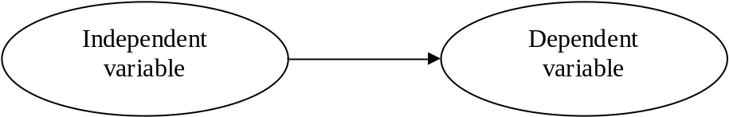
Figure 1. The style name for this kind of paragraph is "Figure title". The style for the figure is called "Figure". The title should always be placed below the figure.
Tables should be titled like the example shows below, the style "Figure title" is also used for the title here.
<One blank line of basic text is needed here!>
Question | Average 1992 | Average 1999
1 How do you regard... | 3.4 | 3.7
2 How do you... | 2.7 | 3.4
3 How do you... | 3.9 | 3.6
Table 2. The style name for this kind of paragraph is "Figure title". The title should always be placed below the table. The table may not extend the margins. The style for the text in table cells is called "Table". Some cells may need special alignment.
Here is an example of using the style "Bullet":
- The style "Bullet" should be used here. This is a complementary sentence. This is a complementary sentence. In the following you can find an example of a second level list:
  - The style "Bullet 2" should be used here. This is a complementary sentence. This is a complementary sentence. This is a complementary sentence. This is a complementary sentence. This is a complementary sentence. This is a complementary sentence.
  - This is a complementary sentence. This is a complementary sentence.
- This is a complementary sentence. This is a complementary sentence. This is a complementary sentence. This is a complementary sentence. This is a complementary sentence. This is a complementary sentence. This is a complementary sentence.
The reference list should look like the examples below. The style is called "Reference list". Use the Harvard citation style reference style (see example below).
Please note that authors submitting papers in different styles will be asked to re-submit using the present template.

References (style "Subtitle" here)
Hamel, G., and Breen, B. 2007. The Future of Management, Boston: Harvard Business School Press.
Hopkins, M. S. 2010. “The Four Ways IT Is Revolutionizing Innovation,” MIT Sloan Management Review (51:3), pp. 51-56.
Huston, L.,and Sakkab, N. 2006. “Connect and Develop: Inside Proctor & Gamble’s New Model for Innovation,” Harvard Business Review (84:3), pp. 58-66.

Footnotes are not recommended, but if used, they should look like this. The style is "Footnote text".

